**SOFTWARE ENGINEERING LAB TASK 6**

**08-01-2025**

**HU22CSEN0100287**

**SAI GANESH ESWARAPRASAD**

**Aim:**

Develop weather modeling using the quadratic model using Waterfall model.

**Waterfall Model:**

The Waterfall Model is a traditional software development methodology that follows a linear and sequential approach. Each phase must be completed before moving to the next.

**Phases:**

1. **Requirement Analysis**
   * Gather all relevant data sources for weather modeling, such as temperature and humidity.
   * Specify the requirements for a quadratic model and the desired outputs.
2. **Design**
   * Develop a mathematical representation of the quadratic model: y=ax2+bx+cy = ax^2 + bx + cy=ax2+bx+c.
   * Create data structures and flowcharts to outline the process.
3. **Implementation**
   * Write the code for the quadratic model using a chosen programming language, such as Python.
4. **Verification**
   * Test the model's predictions by comparing them with historical weather data.
5. **Deployment**
   * Deliver the final system for practical use.
6. **Maintenance**
   * Periodically review and update the model to ensure accuracy and relevance.

**Steps Of Implementation:**

1. Library Imports

imports **NumPy** for numerical computations and **Matplotlib** for creating visualizations.

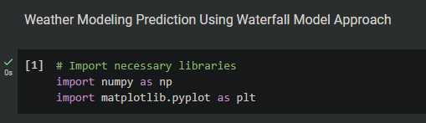

1. Define Quadratic Function

Defines a quadratic function y=ax2+bx+cy = ax^2 + bx + cy=ax2+bx+c, which will model the values for the stages of the Waterfall Model.

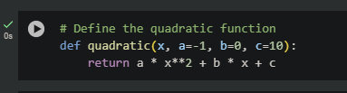

1. Waterfall Model Visualization with Quadratic Curve

This code plots a quadratic curve to represent the stages of the Waterfall Model, with markers and vertical lines creating a waterfall effect between each stage.

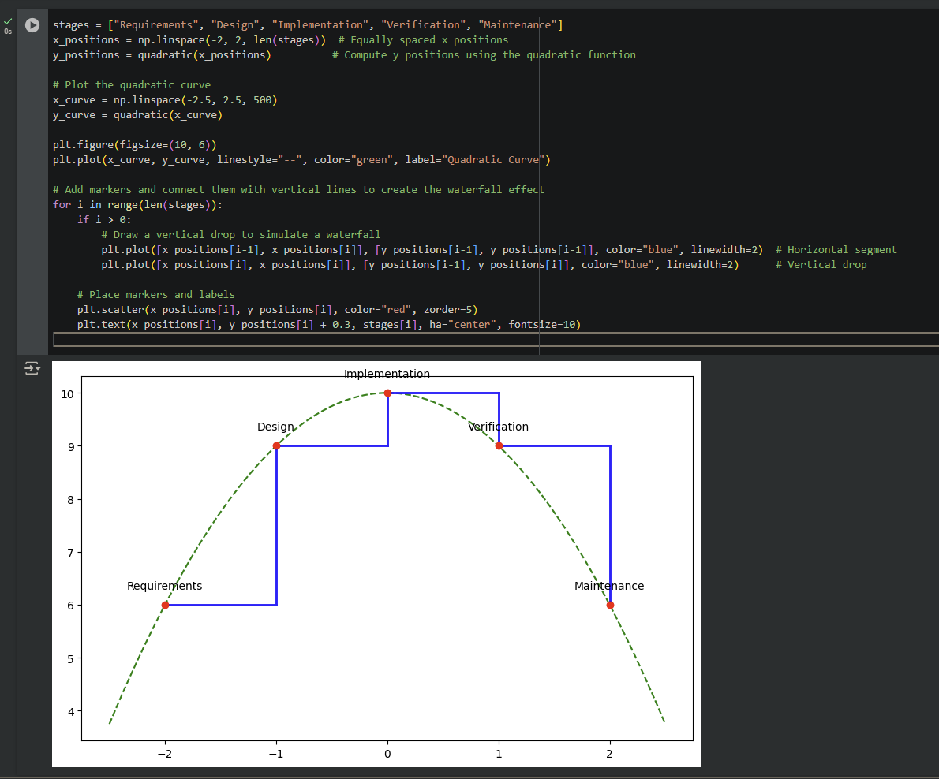

1. Styling and Displaying the Plot

Finalizes the plot by adding titles, axes labels, grid lines, and a legend, then displays the output.

